

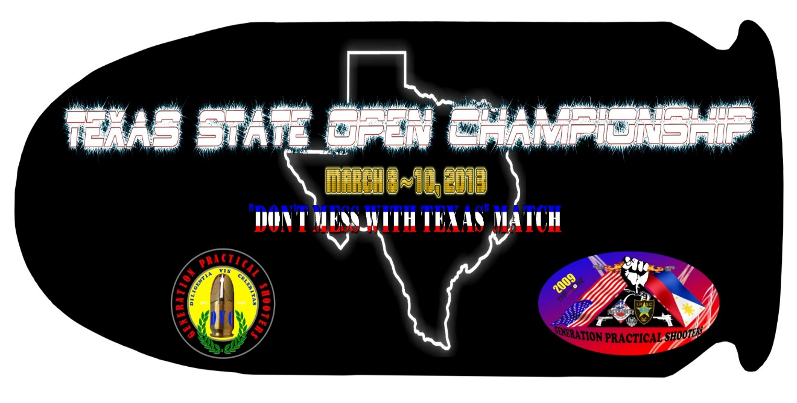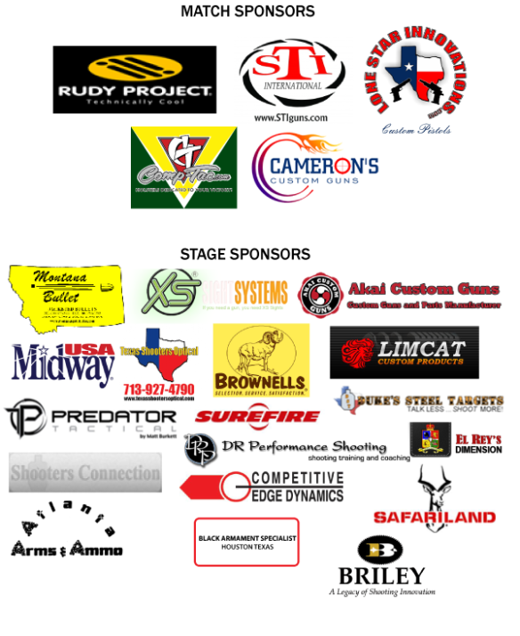[](http://area59.us/)

**Brisco Insurance Agency (*Gary Brisco*)**

**KELLC Range Map**

11

9

Chrono

**General**

**Parking**

R

A

N

D

O

N

S

C

H

O

O

L

R

O

A

D

1

7

5

3

2

4

6

12

10

8

Shooters Meeting / Vendors and Food area.

**Stat**

Squadding Matrix

**RO and Staff on Squad 14-19,**

**Regular Shooters on Squad 20-25**

**Maximum of 8 shooters per squad only.**

**Friday** 7:30 Shooters Meeting

|  |  |  |  |  |  |  |  |  |  |  |  |  |
| --- | --- | --- | --- | --- | --- | --- | --- | --- | --- | --- | --- | --- |
| **Time** | **Stage1** | **Stage-2** | **Stage-3** | **Stage-4** | **Stag-5** | **Stage-6** | **Stage-7** | **Stage-8** | **Stage9**  Chrono | **Stage10** | **Stage11**  **Classifier** | **Stage12** |
| **8:00** | 14 | 15 | 16 | 17 | 18 | 19 | 20 | 21 | 22 | 23 | 24 | 25 |
| **12:30** | Mandatory | Lunch | Time | Everybody | Needs to | stop | Shooting |  |  |  |  |  |
| **1:00** | Resume | Shooting | Until | Done | With all | 12stages |  |  |  |  |  |  |

**Saturday -** Maximum of 10 shooters per Squad.**(**7:45 am mandatory shooters meeting**)**

|  |  |  |  |  |  |  |  |  |  |  |  |  |  |
| --- | --- | --- | --- | --- | --- | --- | --- | --- | --- | --- | --- | --- | --- |
| **Time** | **Stage-1** | **Stage-2** | **Stage-3** | **Stage-4** | **Stage-5** | **Stage-6** | **Stage-7** | **Stage-8** | **Stage-9** | **Stage10** | **Stage11** | **Stage12** | **Break** |
| **8:00** | 1 | 2 | 3 | 4 | 5 | 6 | 7 | 8 | 9 | 10 | 11 | 12 | 13 |
| **12:00** | **L** | **U** | **N** | **C** | **H** |  | **L** | **U** | **N** | **C** | **H** |  |  |
| **6:00** | Make | Sure | Every | one | Finished | All | 12 | Stages |  |  |  |  |  |

**Bucket Raffle**

On behalf of Lone Star Innovations Custom, Generation Practical Shooters, Texas South Section, and KELLC, we want to thank you for being part of our Annual Texas State Match. We will keep you posted for our future matches and events. Be safe going home and we hope everyone had fun.

As for all those who help in planning and setting up stages, even hot weather cannot stop us from achieving our goals and commitments. It is remarkable teamwork and our combined efforts that have brought us this prestigious event. The GPS, KELLC, and Area 59 folks gave it a tremendous 110%. Once again, thank you from the bottom of my heart. God bless us all.

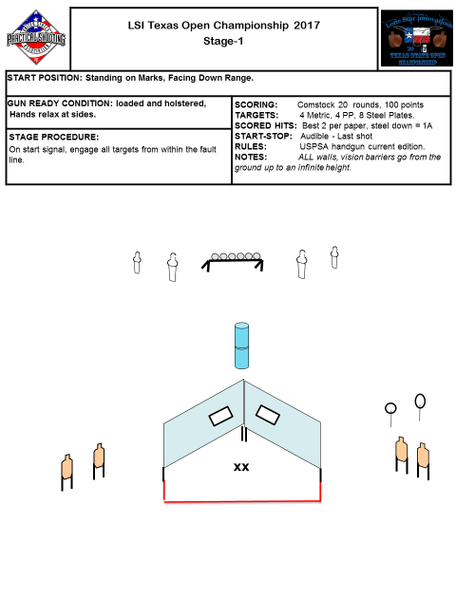

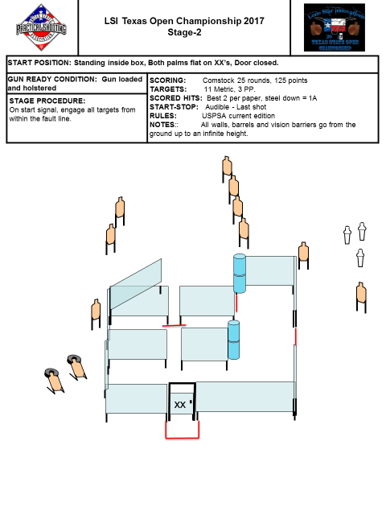

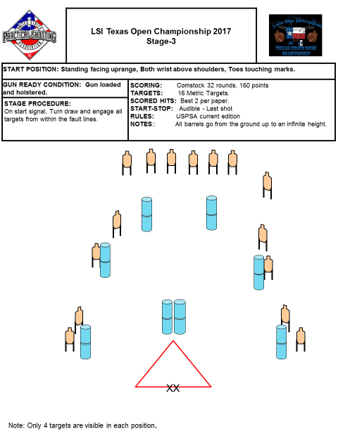

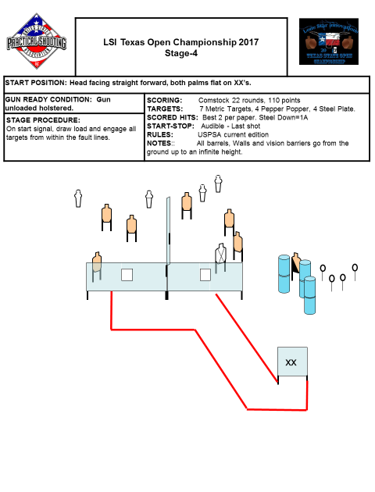

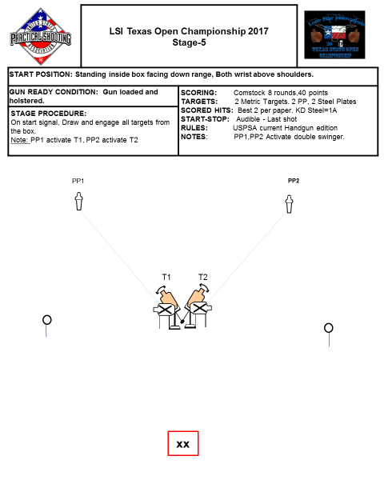

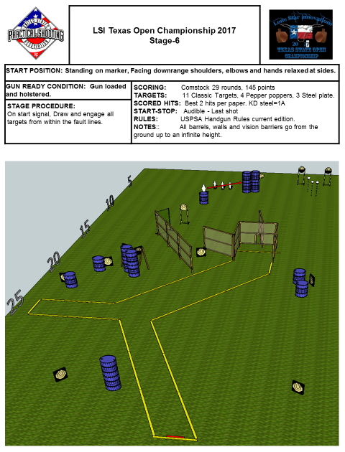

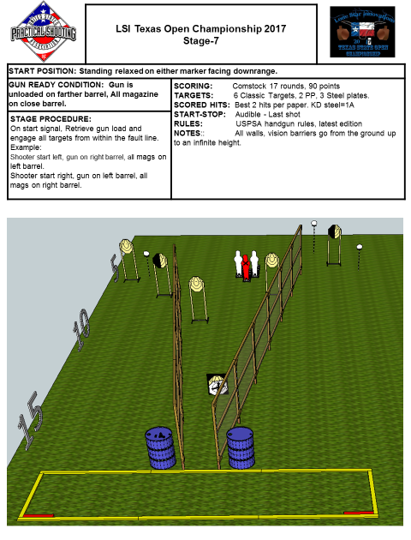

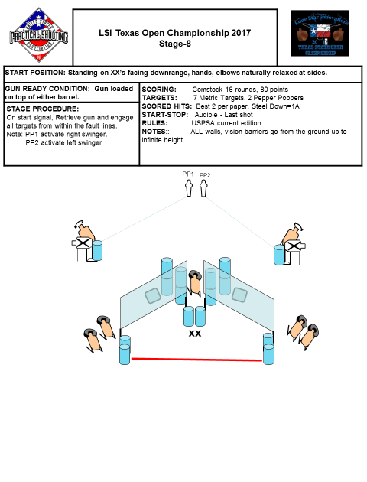

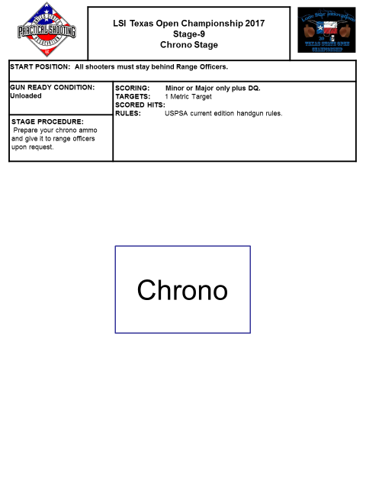

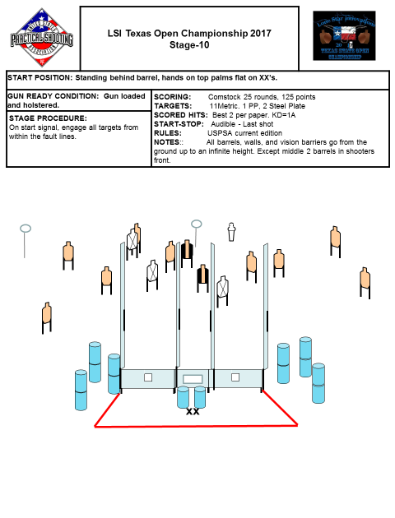

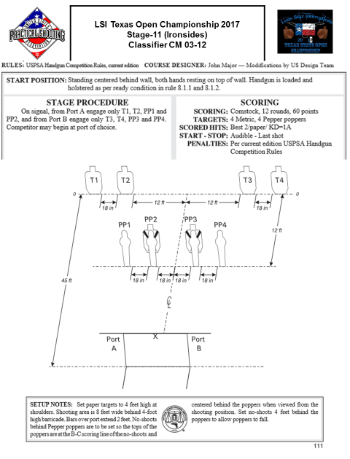

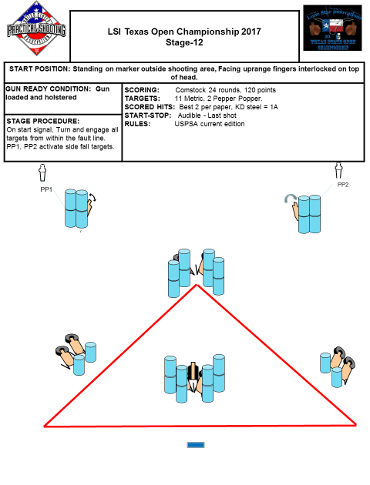

**Match Rules**

**This is a state match that follows USPSA level II Rule Book guidelines.**

**Cold Range**

The KELLC range and Generation Practical Shooters has a cold range policy. Guns will be unloaded and holstered or bagged when the shooter is on the range, except for checking and cleaning in designated safety areas which will be clearly marked.

All guns are to be loaded only on the firing line under the direction of the range officer.

**Stage Diagrams**

Please inspect each stage carefully and ask about any changes. Range masters might have changes for safety reasons. If you do not ask, we will assume that you have noted and understood any changes. All vision barriers and walls are considered hard cover and presumed to **extend infinitely**. These stage diagrams shown in this book may differ from the actual stages once it hit the ground.

**Not Permitted**

As we all know, alcohol and other substances that may impair our judgment are not permitted at this match, if you get caught under the influence of a prohibited substance or alcohol, you will be asked to leave the range and will not be allowed to participate in our future matches.

**Awards**

**We recognize these following divisions:**

Open Limited Production Single Stack

Revolver Carry Optics PCC

**NOTE:**

Special recognition goes to the HOA winner in Open division that resides in Texas for a minimum of 1 year. This is what the Texas State Open Championship stands for. Plaques will be awarded according to the number of participants in each class or category, there must be at least 7 shooters in a class to award 1st, 2nd and 3rd place awards otherwise there’s just the 1st place award.

**Prize Table**

Bucket raffle, each shooter issued 5 tickets. Drop it to desired bucket with your name or contact info.

NOTE: See **Glenn**

**Rasch** for FFL transfer for guns.

**LSI Texas State Open Championship 2017**

Award and prize table substitute form

If you are unable to claim your award/prize table you may designate your representative to claim in your behalf. Complete this form and turn it into the Registration/Prize desk.

Shooter’s name:

USPSA#:

Representative’s name:

Shooter’s Signature:



**Range Officers Assignment 2017**

**Stage RO’s**

**1** Gary Brisco, Eric McCambel, Henry Moreno

**2** Brett Thompson, John Austria

**3** Jim Barret, Veny Villina

**4** Jack Sweet, Chev Jacot

**5** Bill Hunter, Dale Hamm

**6** Scott Coneby, Jason Brinkley

**7** Mike Reed, Jason Wells

**8** Mike Wilson, William Chan

**9 Chrono** Phil Fenley, Paolo Ilagan

**10** Betty Krumholz, Michelle Lonergan

**11** Ken Matthews, Gil Yolo

**12** David Eickhoff, David Chow

**Shooters Services** Walter Knur

**Registration Prizes** Patty Leslie and Ashley Sullivan

**Range Master** Danny Garza, **PCC-**Larry Harrison

**Quarter Master** Carlos Escandon

**Match Directors** Alex Casis and Kent Leslie